QUALITY PLAN

# I. Overview

**System Overview**

This quality plan focuses on Emergency Communications Nodes or E-Nodes. It is a system that comprises of a mesh network and a web application that is hosted on it. It is designed to act as a temporary networking solution to establish communication between disaster response teams.

**System Description**

The system will consist of a hardware and a software component. The hardware part will be the portable mesh network nodes composed of Raspberry Pis with attachments such as Wi-fi dongles, external battery packs, and its weather resistant casing. This is the base of the whole system as it will be where the software component will be hosted on. The software component of this system will be a web application that will be hosted on multiple nodes of the network.

The nodes will be interconnected to create a partial mesh network. These nodes will relay the information to other nodes through protocols that in effect will establish reliable communication between the end devices. Each node will also act as an access point that an end device (smartphone) can connect to with the proper WPA2 passcode. When connected to the access point, the user can access the software component via a web browser.

**

*Figure 1.Partial Mesh network. The black dots represent nodes while the dashed circles show their ranges.*

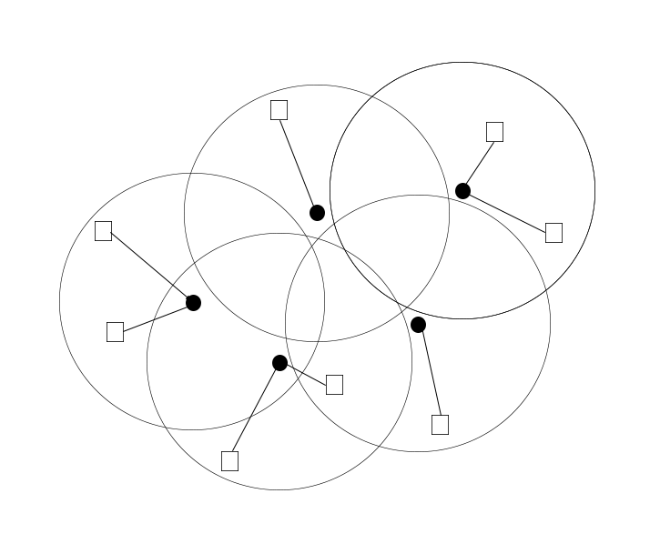

*Figure 2.Access point setup. The black dots represent nodes as access points, the circles show their network ranges and the rectangles represent smartphones connected to the network.*

The web service will be an application that will cater to the needs of rescue and recovery teams during post-disaster scenarios to provide an avenue of communication in times where communications infrastructure is down or just not accessible. It will come with multiple features such as offline maps, personal mailbox, bulletin board and a distress button that will alert other users of a response team's location and situation. It will also include a map plotting feature where users can plot resource needs on the map based on the 4 main needs, water, food, medicine and rescue which will help in the planning and implementation stage of the recovery process.

When the end user connects to the network and does an action in the web application, post a message for example, the event will update the database behind the web server. The nodes will then broadcast the data across the network so that each node that will provide the web service will synchronize their respective databases. The message is then viewed in the web service at the particular access point where another end user's smartphone is connected to.

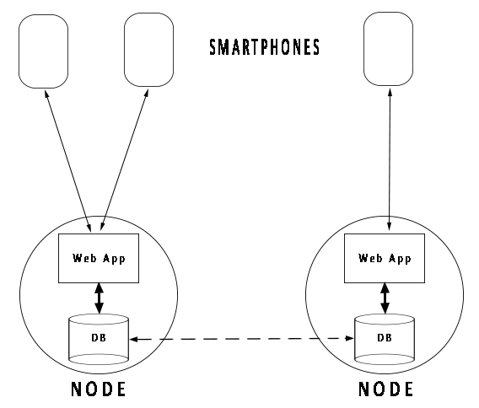

*Figure 3.Web application setup.*

The network is easily scalable because the number of individual nodes can be increased and decreased as the situation demands. Having more nodes creates a network that accommodates a bigger land area which increases the range and effectiveness of the network.

# II. Scope

This quality plan will ensure the network quality of the component and the functionality of the web application. It will also ensure the solutions applicability for natural disaster response for rescue and/or recovery in the Philippine setting.

The smartphones' browser will be tested for this quality plan. The minimum requirements for the browser are as follows: HTML5, CSS3, and Javascript.

With regards to the tests on different environments, the nodes will be tested on two different settings which are line of sight. (i.e. Open fields within Metro Manila) and obstructed areas.

# III. Constraints and Limitations

**Software**

The web application that the group will be developing is expected to be applicable only to mesh networks. The app will be tested using the wireless mesh network that the group developed. The software is limited to sending and receiving messages, posting on a bulletin board and sharing map locations.

The aesthetics of the UI will not be considered as the focus for this system would be usability.

**Hardware**

The group can only test the system to a maximum of 2-hops and couldn’t simulate the multi-hop capabilities of a full mesh network because of budget constraints and limited availability of the raspberry pi model 3B. The group could not also simulate the network’s self—healing capabilities since this kind of test needs more nodes.

The group is limited to testing one specific Wi-Fi dongle, Tenda W311U since it is the cheapest among the other models of Wi-Fi dongles that is compatible with Raspbian and is also readily available in Metro Manila. When testing the network signal, the shape of the antenna, the Wi-Fi signal propagation, and obstacles’ materials will not be considered.

Currently, Raspberry Pis are mostly used indoors and does not have a decent full weatherproof casing readily available for the consumers. Most of the casings that the group has seen were customized to suit a specific purpose. The casing that will be created for this system will be built to withstand exposure to environmental elements commonly found in the Philippines.

**Environment**

The group will not test the system on different geographical locations such as mountains and mountain ranges, mossy and rain forests, and deserts. Like other electronic circuitry and devices, the raspberry pi is also vulnerable to direct water contact. The casing that the group will come up with will only be resilient to light rain. It will not be able to withstand typhoons as it is only intended to be used post-disaster. It will also not be protected from floods in case the whole device falls into a pool of water.

Higher operating temperature can greatly affect the performance and the lifespan of any electronic device or module. Any temperature sensitive materials used in the modules can degrade and wear out quickly. Excessive heat greatly affects the electrical resistance of any device and increases the electronic current. Constant exposure to the sun can create further wear and tear to the device on top of while using it so we only test the devices on cases where it is properly deployed, the cover blocking the sun.

One of the silent killers of most electronic devices is dust and dirt. It accumulates overtime and can cause overheating because it adds another layer of insulation to any device. Dust and dirt also causes poor conduction and interferes with the contacts on the universal serial bus hubs. It can also be a breeding ground for insects such as cockroaches, termites, and ants. The results of our reviews and tests will not take into account the possibility of having insects invading our system. We will not allow insects to enter the nodes but for real life applications, we cannot promise that it is not a possibility.

It must also be stated that due to the geography of the Philippines, the hardware's performance will only be tested under the climate of the country, specifically, at NCR. Results on all tests and reviews will be based on the humidity, and current ambient temperature of the country for the months September to January.

It will only be tested over land, with line of sight and without, but can also be used over sea even if not tested there if properly protected from the sea's elements.

# IV. People

## A. Intended clients

**Office of Civil Defense**

The Office of Civil Defense is an organization within the Philippines's Department of National Defense which serves as the implementing arm of the National Disaster Risk Reduction and Management Council (NDRRMC). As such, it has the primary mission of administering a comprehensive national civil defense and disaster risk reduction and management program by providing leadership in the continuous development of strategic and systematic approaches as well as measures to reduce the vulnerabilities and risks to hazards and manage the consequences of disasters.

**Department of National Defense**

The Department of National Defense is the executive department of the Philippine government responsible for guarding against external and internal threats to peace and security in the country. The Department of National Defense exercises executive supervision over the Armed Forces of the Philippines (AFP), the Office of Civil Defense (OCD), the Philippine Veterans Affairs Office (PVAO), the National Defense College of the Philippines (NDCP), and the Government Arsenal (GA). It is also responsible for disaster preparation and management in the country.

**National Disaster Risk Reduction Management Council**

The National Disaster Risk Reduction & Management Council (NDRRMC), formerly known as the National Disaster Coordinating Council (NDCC), is a working group of various government, non-government, civil sector and private sector organizations of the Government of the Republic of the Philippines established by Republic Act 10121 of 2009. It is administered by the Office of Civil Defense under the Department of National Defense. The Council is responsible for ensuring the protection and welfare of the people during disasters or emergencies.

## B. Team members

**Alfonsin Tison**

Chief Web Developer | Network Engineer | Software Quality Assurance

atison@student.apc.edu.ph

**Allen Rodri Ellana**

Database Designer | Software Quality Control

aaellana@student.apc.edu.ph

**Tomio Tonoike**

Network Engineer | Hardware Quality Assurance

tstonoike@student.apc.edu.ph

**Benjamin Rivera**

Network Engineer | Project Manager | Hardware Quality Assurance

bhrivera@student.apc.edu.ph

## C. Roles and Responsibilities

**Web Developer**

Web developers are responsible for designing and coding the web application. It is their job to utilize necessary tools in order to build the app following the best practices in coding and comply with client’s specifications. As they are the ones who develop the app, it is their responsibility to lead code reviews in order to inform other members of the team about the structure of the codes.

**Network Engineer**

Network engineers are in charge of setting up the hardware and enable its connectivity. They will research, utilize, and test software packages and routing protocols that can be used in enabling and improving the network connectivity of the system. It is also their responsibility to troubleshoot any problems that may arise related to computer networking. As the system is being built, they should be in constant search for ways in optimizing the network of the system. They will also decide which metrics to use when testing the network as a consultant of the quality assurance for hardware.

**Software Quality Assurance Specialist**

Software quality assurance specialists will monitor and guide the software development process of the system. They will always take into consideration the company’s set standards when reviewing other team members’ software output. When issues are encountered along the software development, it is their duty to help in finding possible solutions and revise the process as needed.

**Database Designer**

The database designer designs, implements and manages the system databases. They will be working closely with the web developers to ensure that the database is optimized for the web application and the network.

**Software Quality Control**

Software quality control will design the test cases to be performed in order to measure the software capabilities of the system. They will lead the testing of each software module to ensure that all metrics are measured correctly and create recommendations based on the results.

**Hardware Quality Assurance Specialist**

Hardware quality assurance specialist will be responsible for the proper selection and procurement of all hardware in the system. It is their duty to ensure that all hardware are fully integrated into the system and are also correctly utilized as to not waste any company resources. When a hardware problem is found, they should work together with the network engineer to solve the said issue.

**Project Manager**

The project manager will be acting as the leader of the system development team. He will play a huge role in the planning as it is his duty to oversee each individual role’s processes and their interactions. He will be the one in charge of creating a realistic schedule for the development process of the whole system. He will maintain the motivation of each member to follow the schedule and deliver quality work on time. He is also the one in charge of making executive decisions when changes in the system, schedule or process are due.

# V. Quality Objectives

|  |  |  |
| --- | --- | --- |
| **Disaster Response Communications Software** | | |
| Objective | Technique | Needed Measurement |
| Intended features working | Usability Test | 90% and greater |
| Web Application Error free | User reports | 80% and greater |
| Web Application Bug free | Constant Debugging | 90% and greater (before release) |
| Chat Communication Delay | Field Tests | 3 seconds or less |
|  |  |  |
| **Emergency Node Network** | | |
| Understandable Audio via the Walkietooth application | Transcribe audio on one end while tester reads text from another end | 80% and greater words recognized properly |
| Compatibility to Wi-Fi enabled Smartphones manufactured after 2012 | Test using virtual devices if the network is usable | 80% are compatible |
| Data loss with transmission between mesh nodes (2-hops) | Ping tests w/ and w/o obstacles | 10% or less packet loss |
| Data transfer speed between mesh nodes (2-hops) | File transfers w/ and w/o obstacles | 250ms at 75% of maximum range as distance between 2 nodes |
| Persistent data synchronization  (Optimistic Concurrency) across the mesh (2 hops) | Database update logs (time-stamps) | 5s or less difference in updates |
|  |  |  |

# VI. Quality Assurance Checkpoints

## A. Reviews to be conducted

|  |  |  |
| --- | --- | --- |
| **Review** | **Schedule** | **Description** |
| Documentation | Twice a month | Review the current state of the documentation to minimize any errors and inconsistencies. The documentation should also be updated regularly to be on the same phase with the development of the prototype. |
| Pi's Software | Once a month | Some of software packages used in the systemare still in development stage so updates are expected. This review will be done to ensure that all of the software used are up to date and also to make the team aware of any changes applied to them. |
| Integration | Once a week | Because of expected software updates, it may be possible for the web application prototype to have some compatibility issues with the updated software of the Pi. |
| Code | Once a week | Not all members of the team will be involved in all aspects of the system like programming. However, it is important for all team members to be able to understand how the web application code works. This review will improve the quality of the code in terms of its readability, formatting, and program structure. |

## B. How will you perform these reviews? Using flowcharts

**Documentation Review**

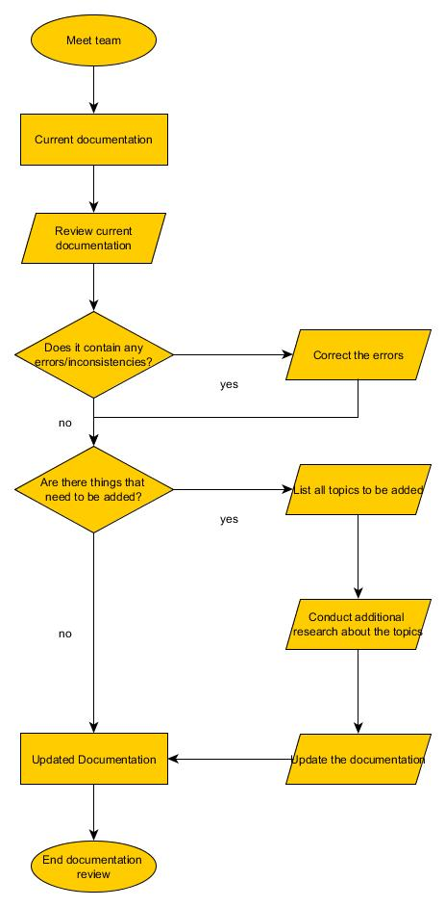

**Pi's Software Review**

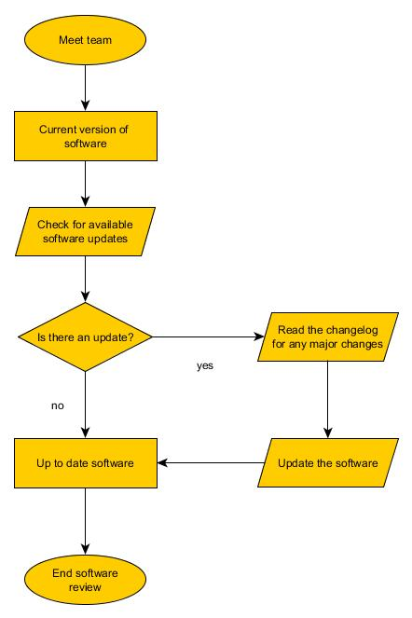

**Integration Review**

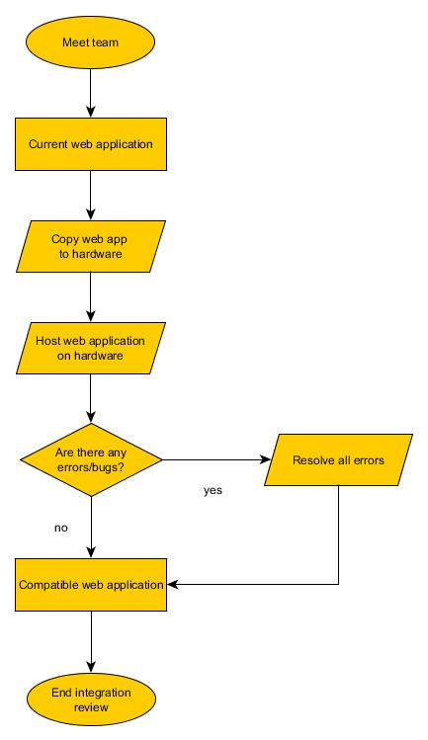

**Code Review**

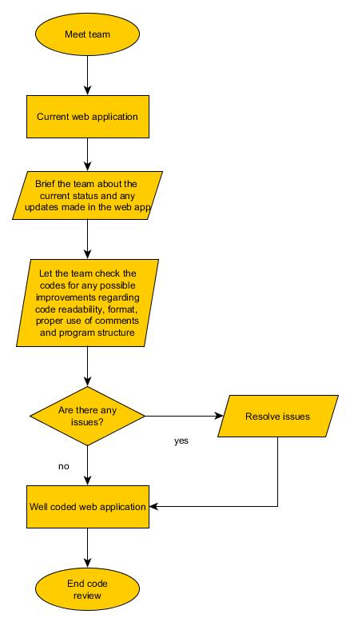

# VII. Deliverables

|  |  |  |  |  |  |
| --- | --- | --- | --- | --- | --- |
| **Deliverable** | **Schedule** | **Technique** | **Participants** | **Communication Medium** | **Remarks** |
|
| Quality Plan | Week 04 |  | All | Email / |  |
| Test Plan | Week 06 |  | All | Email / Facebook messenger |  |
| Network Deployment Plan | Week 07 | Integration Review | Tonoike / Rivera / Ellana | Minutes of the meeting |  |
| Software Deployment Plan | Week 08 | Integration Review / Code Review | Carino / Ellana | Facebook messenger / Email / Minutes of the meeting |  |
| Final Documentation | Week 12 | Documentation Review / Pi's Software Review / Integration Review | All | Facebook messenger / Email / Minutesof the meeting / Status Reports |  |